NEUROTECH ROBOTICS WIREFRAME
Each section represents a page of a website e.g. HOME represents the Home page.
- Logo:
To establish brand identity and consistency across the site. It is positioned at the to-left corner of every page; it acts as a constant anchor reminding users of the club’s name and mission.

- Navigation links:
The navigation bar provides direct access to the main sections (home, about us, projects, events, contact). By being visible on every page, it ensures users can move fluidly without needing to backtrack, this reduces cognitive load and improves user experience.

- Register now button:
It is the primary call to action, used by users to join the club. It is fixed on the top-right corner to ensure accessibility regardless of which page the user is on.by isolating it from the standard navigation links, it stands out to signal its importance and to attract users.

- Home page:
The home page is the entry point of the website. It includes a welcome message, tagline and brief overview of robotics categories which establishes content for new users. Including teasers for upcoming events and featured projects is to create interest in further manoeuvring and explore the website to learn more, so as to align with the principle of web design- “first impressions matter”.

- About Us page:
The section is to communicate the club’s goals, identity and objectives to users. It provides clarity to prospective members and supports informed decision making by listing categories of robotics classes offered. the content is concise yet informative, good enough for an introductory page.

- Projects page:
The gallery of completed and ongoing projects that acts as a portfolio, to show achievements and current work. Prototype images to ensure accessibility for all users including those using screen readers and to follow web standards.

- Events page:
Event time and robotics category provides essential logistical details so members or users can plan attendance and workshops & competitions listed chronologically to organise events in a clear timeline making it easier to track upcoming opportunities.

- Contact page:
Email link to offer direct communication with the club, social media links to expand reach and engagement beyond the website. Copy right adds professionalism and signals ownership of content.

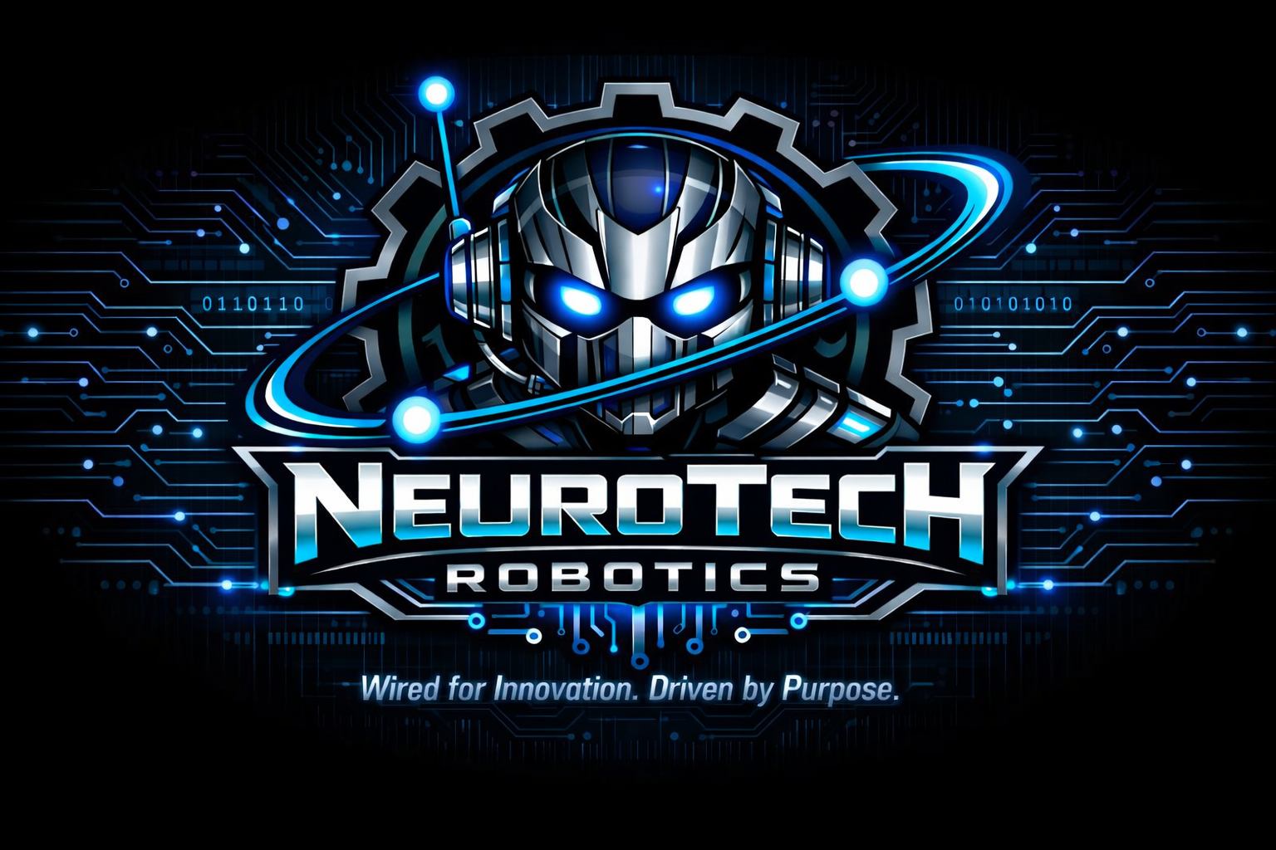

HOME
ABOUT US
PROJECTS
EVENTS
CONTACT
Register now
HOME
WELCOME MESSAGE UPCOMING EVENT TEASER
TAGLINE FEATURED PROJECTS
BRIEF ROBOTICS CATEGORIES UPCOMING EVENT TEASER

ABOUT US
CLUB INTRODUCTION, GOAL, OBJECTIVE
CATEGORIES OF (ROBOTICS) CLASSES OFFERED

CONTACT
EMAIL LINK
SOCIAL MEDIA LINKS
COPY RIGHT

PROJECTS
GALLERY OF PROJECTS COMPLETED AND ONGOING
PROTOTYPE IMAGES WITH ALT TEXT

EVENTS
EVENT TIME AND CATEGORY OF ROBOTICS
WORKSHOPS & COMPETITIONS LISTED CHRONOLOGICALLY

